# Acceptance Testing:

**UAT Execution & Report Submission**

|  |  |
| --- | --- |
| Date | 18 November 2022 |
| Team ID | PNT2022TMID51181 |
| Project Name | Visualizing and Predicting Heart Diseaseswith an Interactive DashBoard |
| Maximum Marks | 4 Marks |

1. **Purpose of Document**

The purpose of this document is to brieflyexplain the test coverage and op issues of the [ProductName] projectat the time of the releaseto Us Acceptance Testing (UAT).

# Defect Analysis

This report shows the number of resolved or closed bugs at each severitylevel, and how they were resolved

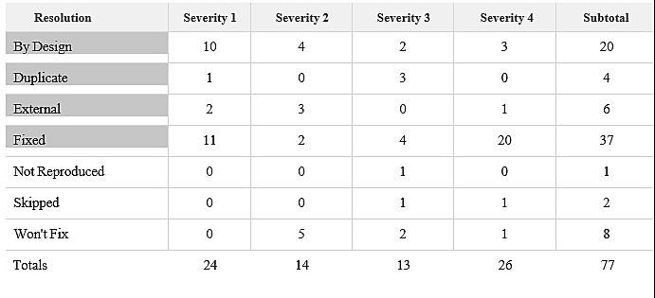

# Test Case Analysis

This reportshows the number of test cases that have passed, failed,and untested

|  |  |  |  |  |
| --- | --- | --- | --- | --- |
| **Section** | **Total Cases** | **Not Tested** | **Fail** | **Pass** |
| Print Engine | 7 | 0 | 0 | 7 |
| Client Application | 51 | 0 | 0 | 51 |
| Security | 2 | 0 | 0 | 2 |
| Outsource Shipping | 3 | 0 | 0 | 3 |
| Exception Reporting | 9 | 0 | 0 | 9 |
| Final ReportOutput | 4 | 0 | 0 | 4 |
| Version Control | 2 | 0 | 0 | 2 |